# Objective

In this tutorial, we will write python class to control LCD 1602 using I2C interface of Raspi. Through this experiment, you should master the following skills:

1. Know the basic knowledge of LCD 1602;
2. Use the I2C interface of Raspberry Pi to control LCD 1602;
3. Learn to write a Python class of LCD 1602;
4. Multi task programming using python

# Components

1. Raspi Board and Power；

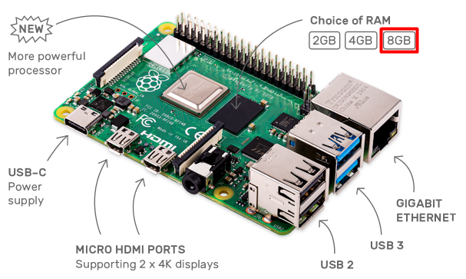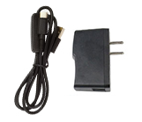

1. A 16GB SD Card and a SD Card Reader；

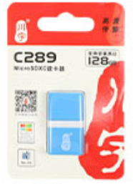

1. HDMI Screen, USB keyboard, USB mouse and HDMI Cable

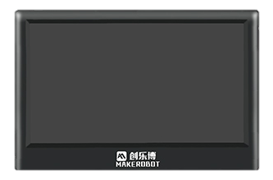

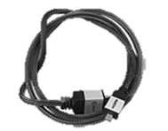

1. Basic Hardware (Adapter Board, Wires, Bread Board)

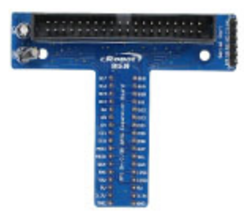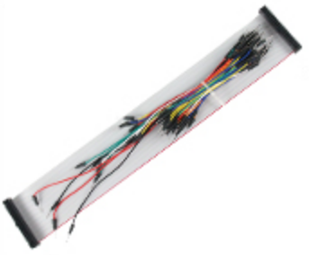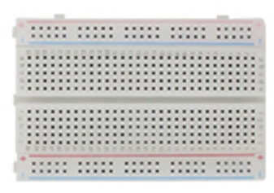

1. LCD 1602

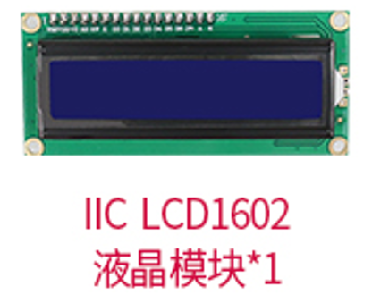

1. KEY

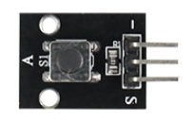

# Basic Knowledge for the Experiment

## **I2C Protocol**

I2C is alternatively known as I2C or IIC. It is a synchronous, multi-master, multi-slave, serial communication bus. Due to I2C only has two wires, Serial Data Line (SDA) and Serial Clock Line (SCL), pulled up with resistors, it’s popularly used in many IoT sensors. In an I2C system as below, there are three slaves and each slave has a separate address.

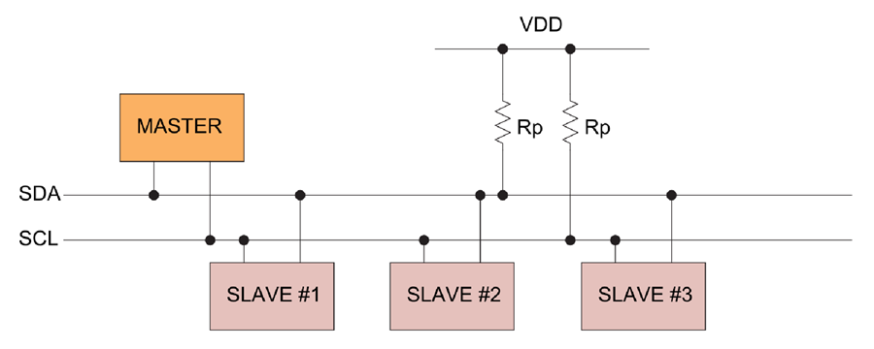

For Python programing, the smbus library can be used to undertake I2C communication. We should first use the SMBus class of smbus library to create I2C slave according to its address. And then use write_byte function to transfer data to slave. The steps to transfer data through I2C is shown as below:

* Import smbus library

import smbus

* Create a smbus device for the I2C interface of Raspi

bus = smbus.SMBus(1)

This code creates an I2C device for */dev/i2c-1* of Raspi

* Transfer data through I2C interface

bus.write_byte(addr,data)

Here, addr is the I2C slave address and data is the data to be transfered.

There are some other functions in smbus library, which are described as below:

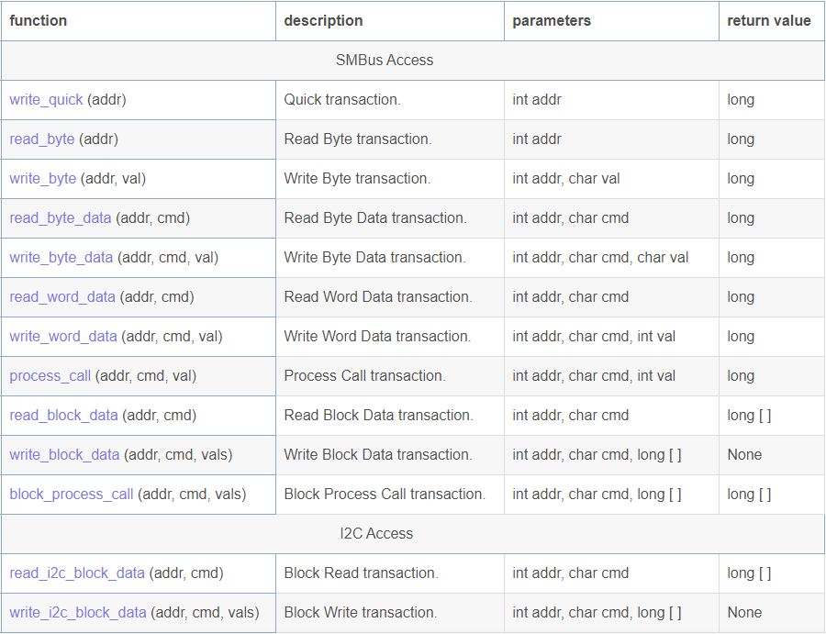

## LCD 1602

LCD 1602 is an easy to use LCD screen which could display 2 lines of 16 characters at most. Generally, LCD1602 has parallel ports, that is, it needs several pins at the same time to transfer data. And it can also be categorized into eight-data-port and four-data-port connections.

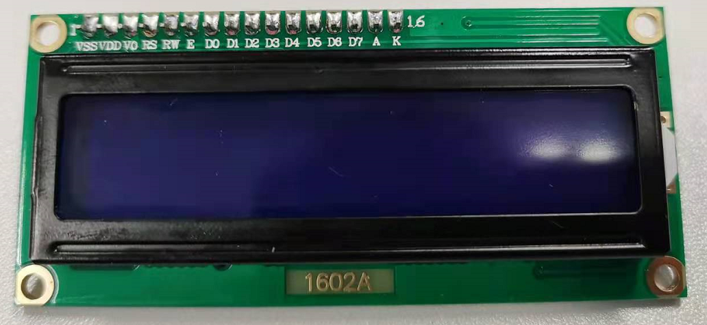

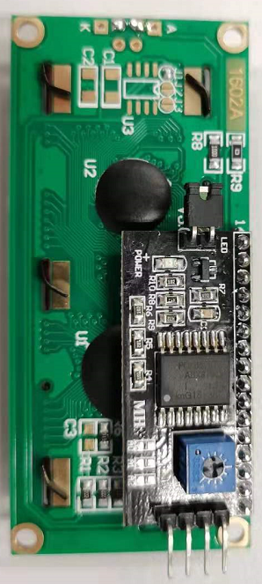

The function of each pin is shown as below:

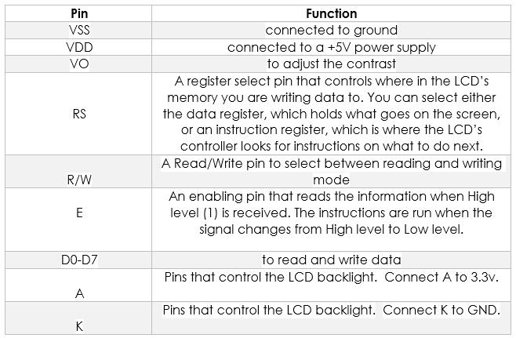

The detail function of each pin is shown in the table as below, for more information, please read the datasheet of LCD1602.

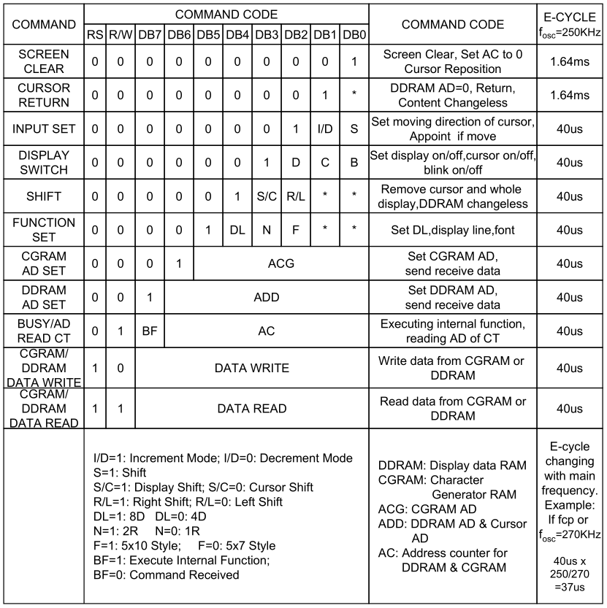

In our experiment, LCD1602 is categorized into four-data-port connections, and an I2C chip is used to further reduce the number of lines. The connection diagram between LCD1602 and I2C chip is shown as below.

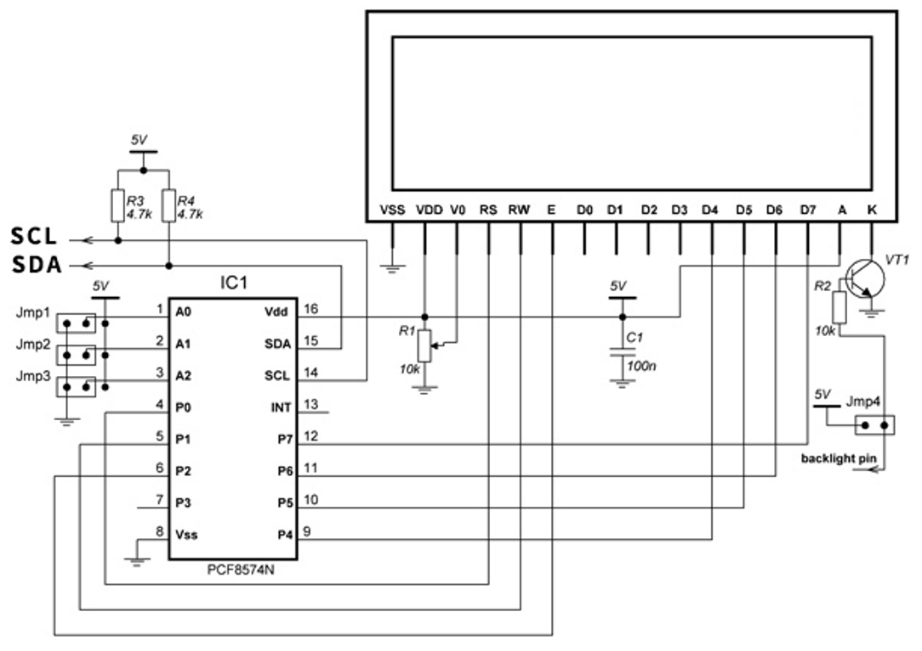

When we first use LCD1602, we should adjust the adjustable resistance highlighted as below until the string are shown clearly, else we may not see anything.



## Multi Task Programing

Modern operating systems allow a user to run several applications simultaneously, so that some tasks can be run in the background while the user continues with other work in the foreground. The user can also run multiple copies of the same program at the same time.

To create a task we can use process or thread. Process has its private resources including memory mapping, files and other os objects. Multiple threads can run on the same process and share all its resources but if one thread fail it will kill all other threads in its process.

Python has many libraries to handle multi-tasking, such as os.fork, multiprocessing library, threading library, and so on. Threads run on the same process address space. It is easy to share data between them, and smaller than process.

In this experiment, we will use the threading library to realize multi task programing. The steps to create multi tasks by threads is shown as below:

* Import the threading library;

import threading

* Write the functions needed for multitasking;

def key_lcd():

while True:

sleep(0.01)

if pin_key.is_pressed:

lcd.show_string(0,1,'Key is Pressed!')

else:

lcd.show_string(0,1,'Key is Released!')

* To create a multiprocessing, create thread class and pass in function reference;

t1 = threading.Thread(target=key_lcd)

* Calls the t1.start() method of the instance object to start up the sub thread, and wait for the end of the sub thread using t1.join() method.

t1.start()

t1.join()

For more detail information about threading library, please click [here](https://docs.python.org/3/library/threading.html).

# Experiment Steps

## Hardware Connection

1. Connect Raspi and Breadboard using the 40-wires cable as below.

This side close to the edge of Raspi

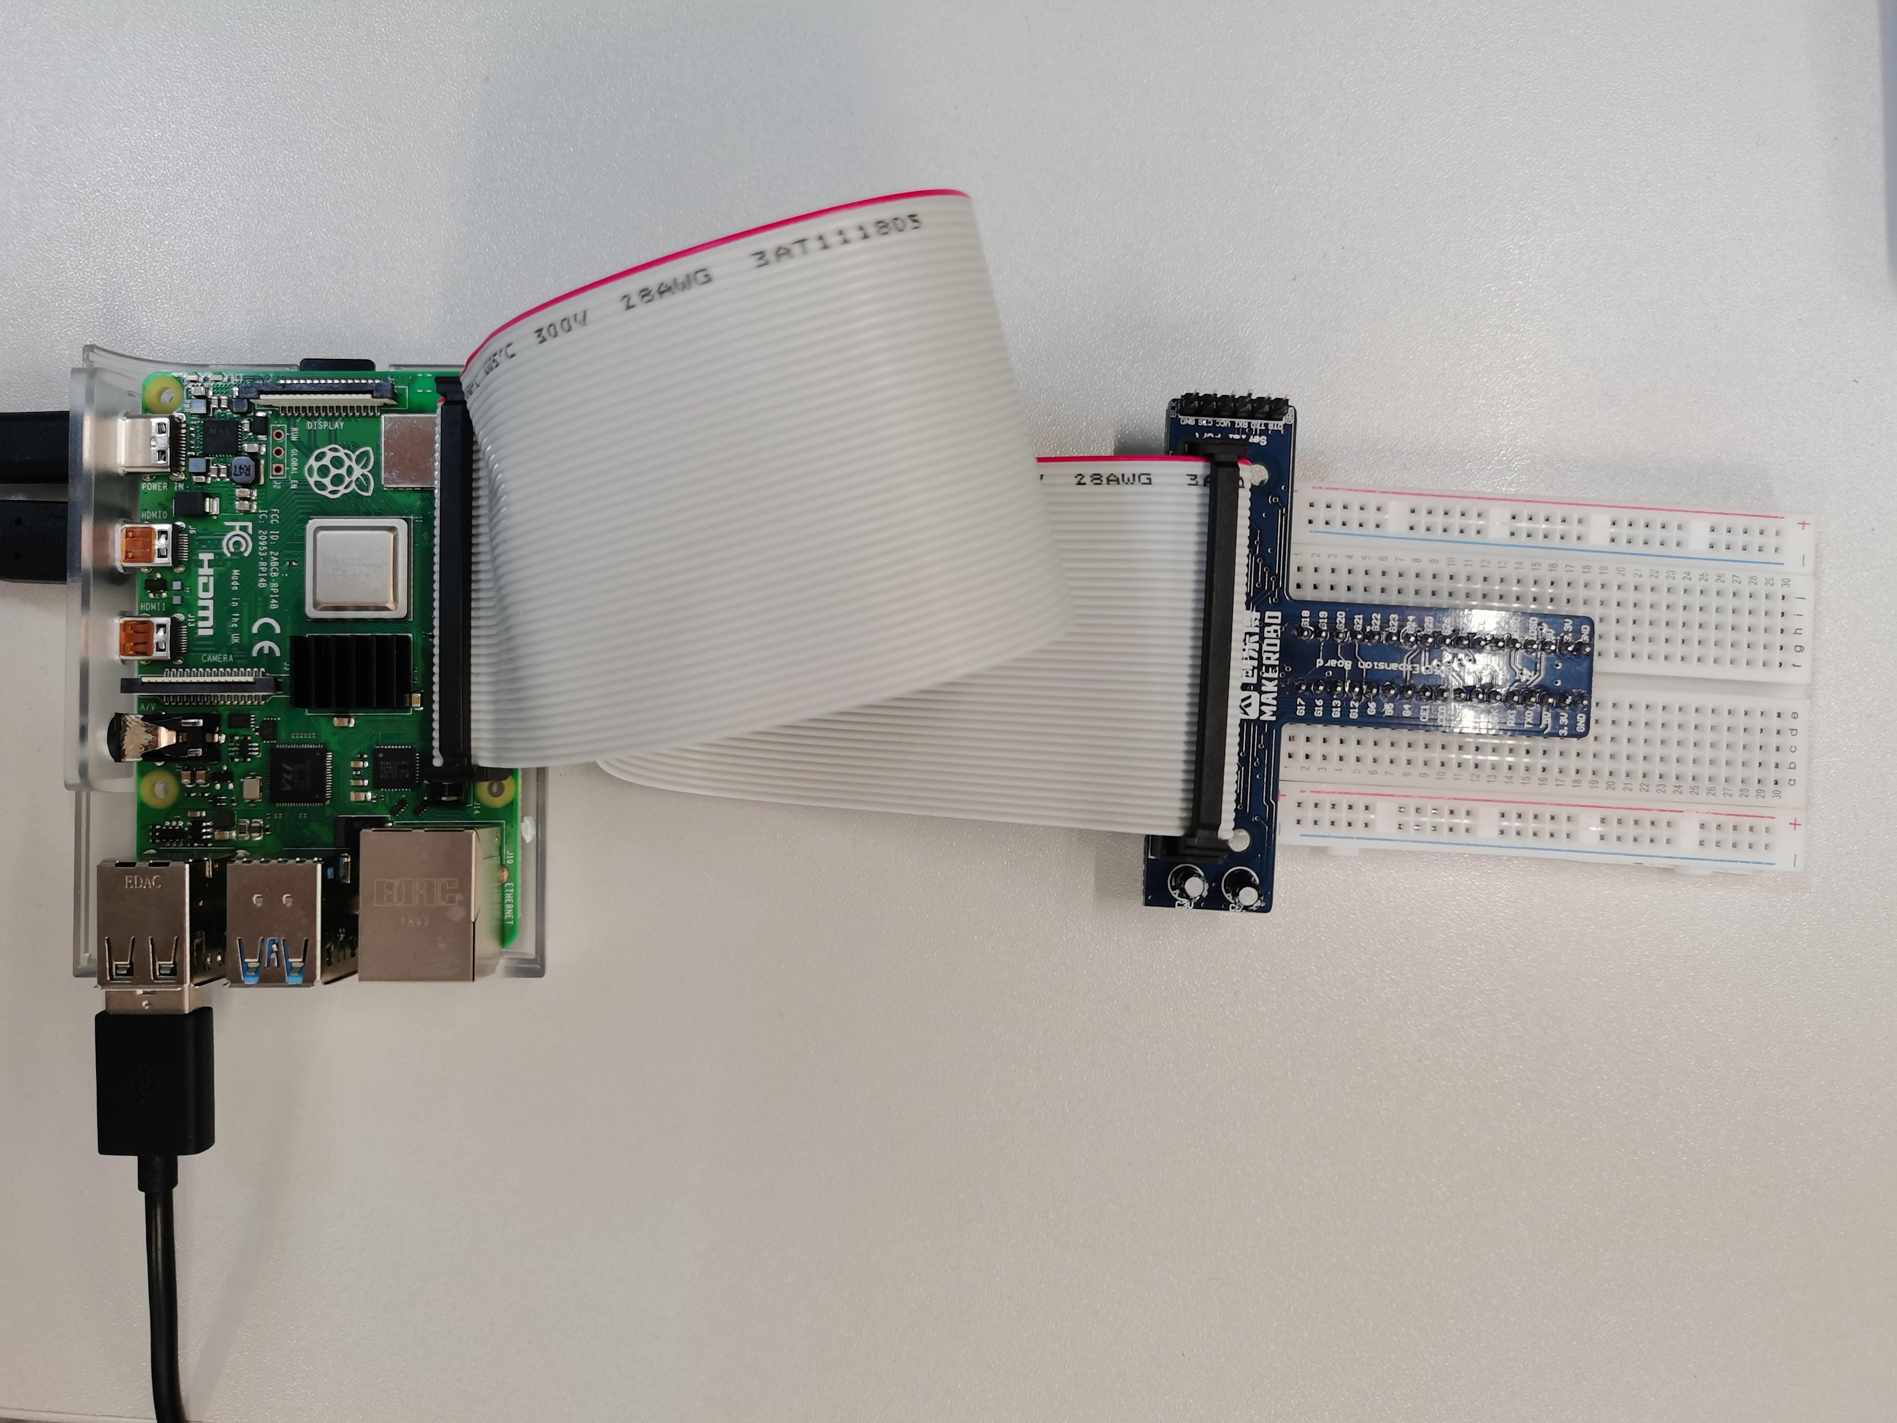

1. Connect KEY and LCD1602 as below.



The final connection is shown as below:

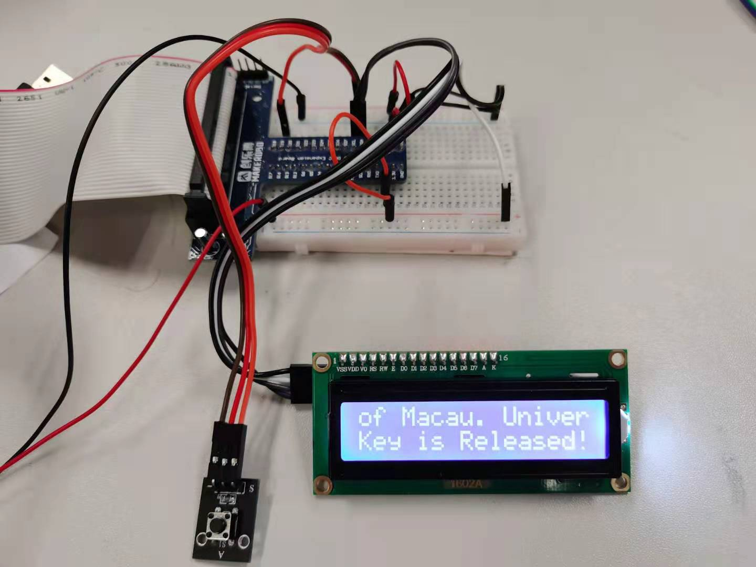

## Check the I2C connection

1. Open Raspberry Pi configuration by clicking **Menu** 🡪 **Preference** 🡪 **Raspberry Pi configuration.**

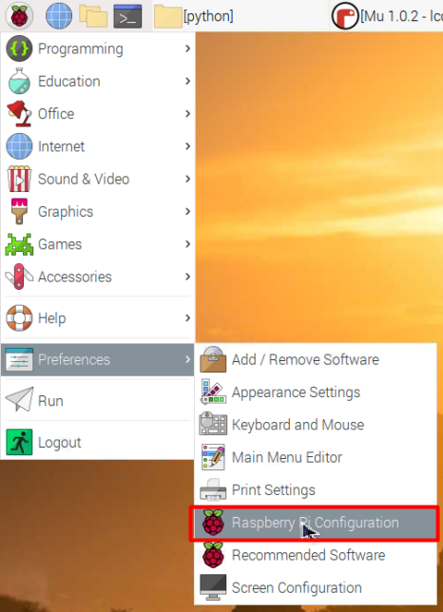

1. In the Raspberry Pi configuration window, click Interfaces and enable I2C interface as below. Then click OK, and reboot the Raspberry Pi OS.

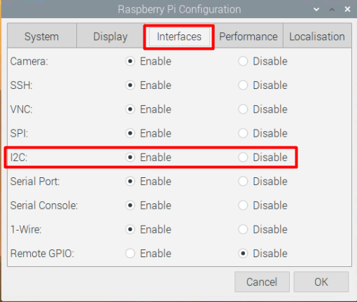

1. After the Raspberry Pi OS restarts, open a command window by click the icon as below and a new window will pop up.

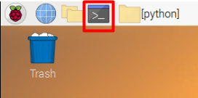

1. In the new command window, input and run the command as below:

$ i2cdetect -y 1

This command detects all the slaves of the */dev/i2c-1* of Raspi and print the corresponding addresses. As shown as below, the address of LCD1602 device is **0x27. It indicates the** LCD1602 hardware device is well connected.

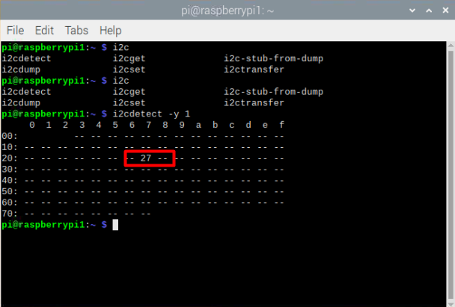

1. Download lcd1602_adjust.py from [here](https://github.com/yg99992/Raspi_code/blob/master/lcd1602_adjust.py), and put it in /home/pi/mu_code/python_code
2. In the command window, input and run the command as below:

python /home/pi/mu_code/python_code/lcd1602_adjust.py 1 0x27

1. Adjust the adjustable resistor until the strings, LCD1602 and Lightness Adjust, are clearly displayed.



Adjust Me

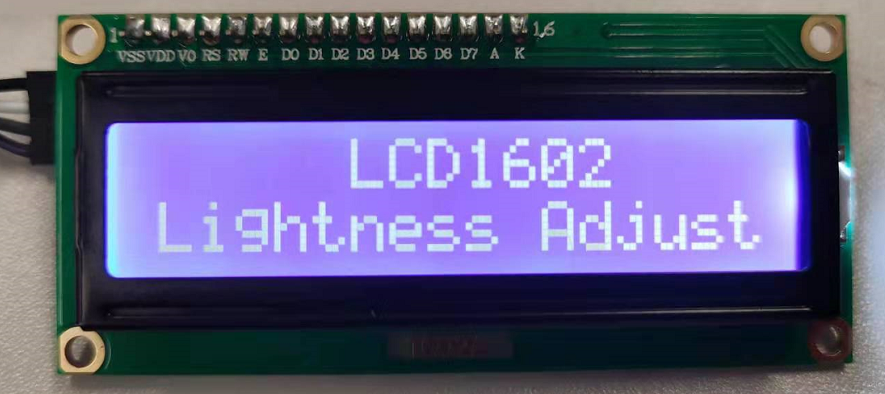

## Software Programing

### Write **lcd1602** class

1. Power on Raspi and start-up Mu from the Raspi menu: **Menu 🡪 Programming 🡪 mu**, as below

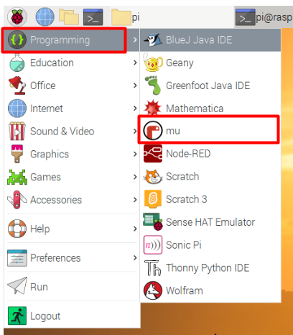

1. Click the New button, then before typing anything, click the Save button and enter the “python_code” folder, and give the file name, “lcd1602.py”, then click Save button.
2. Type the following Python code into the text area to import the useful python libraries:

import smbus

import time

1. Then define the lcd1602 class and write the first function, initial function, in class as below.

class lcd1602:

def __init__(self, i2c_dev = 1, addr = 0x27):

# Define some device parameters

self.I2C_ADDR = addr # I2C device address

self.LCD_WIDTH = 16 # Maximum characters per line

self.LCD_HIGH = 2

# Define some device constants

self.LCD_CHR = 1 # Mode - Sending data

self.LCD_CMD = 0 # Mode - Sending command

self.LCD_BACKLIGHT = 0x08 # On

self.ENABLE = 0b00000100 # Enable bit

# Timing constants

self.PULSE = 0.0005

self.DELAY = 0.0005

# Command

self.CLEAR = 0x01 # screen clear

self.BUSY = False

#Open I2C interface

self.BUS = smbus.SMBus(i2c_dev) # Rev 2 Pi uses 1

# Initialise display

self.lcd_byte(0x33,self.LCD_CMD) # 110011 Initialise

self.lcd_byte(0x32,self.LCD_CMD) # 110010 Initialise

self.lcd_byte(0x06,self.LCD_CMD) # 000110 Cursor direction

self.lcd_byte(0x0C,self.LCD_CMD) # 001100 Display On,Cursor Off, Blink Off

self.lcd_byte(0x28,self.LCD_CMD) # 101000 Data length, number of lines, font size

self.lcd_byte(self.CLEAR,self.LCD_CMD) # 000001 Clear display

time.sleep(self.DELAY)

This function will be executed automatically when we create an LCD1602 module. In def __init__(self, i2c_dev = 1, addr = 0x27), the first input parameter self standards the current lcd1602 class itself. i2c_dev = 1, addr = 0x27 mean the default i2c interface is */dev/i2c-1*, and default address of LCD1602 is 0x27. If we don’t give values for i2c_dev and addr when create LCD1602 module, the default value will be used.

In this function, we first define some parameters for LCD1602, and the create the I2C interface class using self.BUS = smbus.SMBus(i2c_dev). Then some initial command are send to LCD1602 hardware device to set the working mode of LCD1602. If you want to know more about the command code, please read the datasheet of LCD1602.

1. Define command and data transfer function in lcd1602 class as below.

def lcd_byte(self, bits, mode):

# bits = the data

# mode = 1 for data

# 0 for command

bits_high = (bits & 0xF0) | self.LCD_BACKLIGHT | mode

bits_low = ((bits<<4) & 0xF0) | self.LCD_BACKLIGHT | mode

# High bits

self.BUS.write_byte(self.I2C_ADDR, bits_high)

self.lcd_toggle_enable(bits_high)

# Low bits

self.BUS.write_byte(self.I2C_ADDR, bits_low)

self.lcd_toggle_enable(bits_low)

def lcd_toggle_enable(self, bits):

# Toggle enable

time.sleep(self.DELAY)

self.BUS.write_byte(self.I2C_ADDR, (bits | self.ENABLE))

time.sleep(self.PULSE)

self.BUS.write_byte(self.I2C_ADDR,(bits & ~self.ENABLE))

time.sleep(self.DELAY)

The function, def lcd_byte(self, bits, mode), is responsible for transferring one byte data or command to LCD1602 hardware device. The input bits is the 8-bit input command or data that is indicated by the input value of mode. As introduced in 3.2. , LCD1602 is categorized into four-data-port connections, so in this function the 8-bit input command or data are divided into 2 4-bits values and assigned to bits_high and bits_low, respectively. lcd_toggle_enable(self, bits) function is defined according the timing gram of LCD1602 to lock the bits value into LCD1602 by controlling the **ENABLE (E)** pin.

1. Define the string transfer function in lcd1602 class as below.

def show_string(self, lcd_y=0, lcd_x=0, message):

# Send string to display

message = message.ljust(self.LCD_WIDTH," ")

if lcd_x < 0:

lcd_x = 0

if lcd_x >= self.LCD_WIDTH:

lcd_x = self.LCD_WIDTH - 1

if lcd_y <0:

lcd_y = 0

if lcd_y >= self.LCD_HIGH:

lcd_y = self.LCD_HIGH - 1

lcd_addr = 0x80 + 0x40 * lcd_y + lcd_x

self.BUSY = True

self.lcd_byte(lcd_addr, self.LCD_CMD)

for i in range(len(message)):

self.lcd_byte(ord(message[i]),self.LCD_CHR)

#time.sleep(0.2)

self.BUSY = False

This function is a high level function, which display a string on LCD1602. The location of the first char of the string can be appointed by lcd_x and lcd_y, respectively. For LCD1602, 0 ≤ lcd_x ≤ 1, 0 ≤ lcd_y ≤ 15. Besides, ord() is a inter function of python, which converts char into ASCII code. When we send command or data using I2C, the variable self.BUSY is set True, that can be used to avoid conflicting in multi-task application.

1. Finally, define the clear screen function in lcd1602 class.

def clear_screen(self):

self.lcd_byte(self.CLEAR, self.LCD_CMD)

time.sleep(self.DELAY)

According to __init__() function, self.CLEAR = 0x01, this code is the clear screen command of LCD1602.

1. We write the testing code at the end of lcd1602.py to test the lcd1602 class.

if __name__ == '__main__':

lcd = lcd1602(1, 0x27)

lcd.show_string(0, 5, "LCD1602")

lcd.show_string(1, 3, "Hello World!")

if __name__ == '__main__': means that the following code are only executed when we run lcd1602.py directly, while not executed when we import and create lcd1602 class in other python file.

lcd = lcd1602(1, 0x27) creates a LCD1602 class named lcd, and then two strings, LCD1602 and Hello World!, are displayed on LCD1602.

If there are something wrong, you can down load lcd1602.py from [**https://github.com/yg99992/Raspi_code/blob/master/lcd1602.py**](https://github.com/yg99992/Raspi_code/blob/master/lcd1602.py), and compare with your own code.

### Display Key Status

1. Create a new python file, named p04_lcd1602.py, and import the self-defined lcd1602 class and other libraries as below:

from lcd1602 import *

from gpiozero import *

from time import sleep

from time import time

import threading

Please google the difference between import and from XXX import XXX by your self.

1. Write the function key_lcd() as below to display the status of KEY using LCD1602.

global pin_key

global lcd

pin_key = Button(19)

lcd = lcd1602(1)

def key_lcd():

while True:

if pin_key.is_pressed:

lcd.show_string(1,0,'Key is Pressed!')

else:

lcd.show_string(1,0,'Key is Released!')

In this function, we poll the status of KEY. If KEY is pressed, LCD1602 will print Key is Pressed! , else print Key is Released! .

1. At the end of p04_lcd1602.py, write the following code to test key_lcd().

try:

key_lcd()

except KeyboardInterrupt:

lcd.clear_screen()

lcd.BUS.close() # close i2c

print('exit')

try: XXX except KeyboardInterrupt: means when we press Ctrl + c, the program will exit from key_lcd() and the codes in except key words will be executed, then the LCD1602 will be cleared and I2C bus will be closed and the program finish and exit.

1. Press the Run button and observe the LCD1602 screen. The string, Key is Released!, should be displayed on the bottom row. Then press KEY and Key is Pressed! should be displayed.
2. Press Ctrl + c using Keyboard to clear LCD1602 screen, close I2C bus and exit the program.

### Scroll Display

The scroll display can be realized by writing the changing strings into LCD1602 repeatedly.

1. Write a new function lcd_scroll() in p04_lcd1602.py as below.

def lcd_scroll():

string = 'University of Macau. '

inx = 0

str_len = len(string)

while True:

for inx in range(str_len):

str_show = string[inx:] + string[:inx]

lcd.show_string(0, 0, str_show)

sleep(0.4)

str_len = len(string) obtains the length of string.

str_show = string[inx:] + string[:inx] reforms string into a new string str_show. + concatenates two sub strings, and the operation on string is shown as below:

string[start:stop] # items start through stop-1

string[start:] # items start through the rest of the array

string[:stop] # items from the beginning through stop-1

string[:] # a copy of the whole array

1. At the end of p02_button_raspi.py, modify the testing code as below to test the lcd_scroll():

try:

**lcd_scroll**()

except KeyboardInterrupt:

lcd.clear_screen()

lcd.BUS.close() # close i2c

print('exit')

1. Press the Run button and observe the LCD1602 screen. The LCD1602 should scroll left to show string University of Macau.
2. Press Ctrl + c on Keyboard to clear LCD1602 screen, close I2C bus and exit the program.

### Multi-task Programing

It can be observed that both key_lcd() and lcd_scroll() have endless loop. In this subsection, we will create two threads to execute these two functions at the same time.

It’s worthy to mention that the multithreading is not real parallel execution, while the CPU are scheduled to process a thread when other threads are sleeping. So, every endless loop must contains at least sleep() function

1. Modify key_lcd() function and add the highlighted codes as below:

def key_lcd():

while True:

sleep(0.01)

if pin_key.is_pressed:

while lcd.BUSY:

sleep(0.001)

lcd.show_string(1,0,'Key is Pressed!')

else:

while lcd.BUSY:

sleep(0.001)

lcd.show_string(1,0,'Key is Released!')

Warning: If more than one thread use I2C transfer data at the same time, the conflict will occur and further cause garbled on LCD1602. So, before transfer string to LCD1602, the thread should wait until lcd.BUSY is False.

1. Similarly, add the highlighted codes as below: .

def lcd_scroll():

string = 'University of Macau. '

inx = 0

str_len = len(string)

while True:

for inx in range(str_len):

while lcd.BUSY:

sleep(0.001)

str_show = string[inx:] + string[:inx]

lcd.show_string(0, 0, str_show)

sleep(0.4)

1. According to the introduction in 3.3. , change the final testing code to create two threads and pass in the corresponding function references. Then start all threads and block the current thread until all sub threads finish. The corresponding codes are shown as below:

try:

#Muti-threads

threads=[]

t1 = threading.Thread(target=key_lcd)

threads.append(t1)

t2 = threading.Thread(target=lcd_scroll)

threads.append(t2)

for t in threads:

t.start()

t.join()

except KeyboardInterrupt:

lcd.clear_screen()

lcd.BUS.close() # close i2c

print('exit')

threads=[] creates an empty variable threads;

threads.append(t1) appends thread t1 into threads;

for t in threads: obtains all the thread classes and start them.

1. Press the Run button. At the top row of LCD1602, University of Macau. should be scroll displayed. And the KEY status should be displayed on the bottom row of LCD1602 at the same time.



1. Press Ctrl + c on Keyboard to clear LCD1602 screen, close I2C bus and exit the program.

# Task

There are a total of three tasks, you should finish at least two tasks.

1. Modify key_lcd() to realize the functions as below:

* When KEY is Pressed, LCD1602 displays **your name** on the bottom row. When KEY is released, LCD1602 displays Key is Released!
* When KEY is hold more than 2 seconds, LCD1602 display Exit Detection! on the bottom row of LCD1602 and then the program jumps out key_lcd() and return True.

1. Modify lcd_scroll() to realize the functions as below:

* Reverse the scroll direction of string.

1. Further modify lcd_scroll()to realize the functions as below:

* Press KEY once, the string stop scrolling; And press KEY another time, the string scroll continue.

You should create a new thread to detect KEY or modify key_lcd(), and a global variable can be used to determine whether the string is scrolling or static.

# Reference

[**Python Multitasking – Multithreading and Multiprocessing**](https://devarea.com/python-multitasking-multithreading-multiprocessing/)

[**树莓派（Raspberry Pi）python smbus 函数说明**](https://blog.csdn.net/Jacob_zhj/article/details/90518363)

[**树莓派基础：用于Raspberry Pi的基于Python的I2C函数**](https://blog.csdn.net/lovely_yoshino/article/details/113620097?utm_medium=distribute.pc_relevant.none-task-blog-baidujs_title-0&spm=1001.2101.3001.4242)

**End of Tutorial 4**